
(Approx. 685 words)

What is PayPal and how does it work?
https://techboomers.com/t/what-is-paypal

At Techboomers, one of the most common security questions that we get from our users is with respect to websites that require you to pay for something: "is it safe to put my credit card details into this website?" Often, the answer is "yes," but some people are still a little uncomfortable with entering their credit card details into every single website that requires payment, either for a subscription to a service or an item that they want to buy from someone. And with all of the horror stories about how permanent information on the Internet is, and how often others try to steal it (and sometimes succeed), we totally understand that.

That's where a website like PayPal.com is useful. Just enter a few of your personal and financial details into PayPal, and you can use it as a payment method on millions of websites across the Internet, including eBay.com and OverStock.com! And here's the kicker: you don't have to reveal your credit card or bank account details to any of those websites. That's right; authorization of your PayPal account is all that you need to seal the deal!

So what exactly is PayPal?
PayPal is a financial tool that lets you conduct transactions online without entering your financial details into every website you deal with. Link your credit card and/or bank account to PayPal, and then add to (or withdraw from) a secure money pool, shop at retailers who accept PayPal, or send money to other PayPal users.

How does PayPal work? 5 key ways to use PayPal

1. Pay from your credit card or bank account
When you sign up for PayPal, you can link your credit card account, your bank account, or both to your PayPal account. That way, when you pay for something using PayPal, you get to choose where the money comes from!

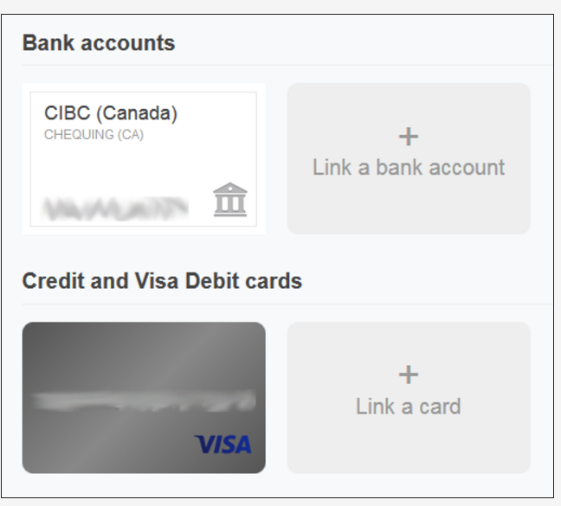

2. Create a secure pool of money
You can transfer money from your bank account to your PayPal account. That way, when you want to send money or pay for something with PayPal, you can just use the money in your PayPal account. You don't have to involve your credit card or bank account details at all in the transaction!
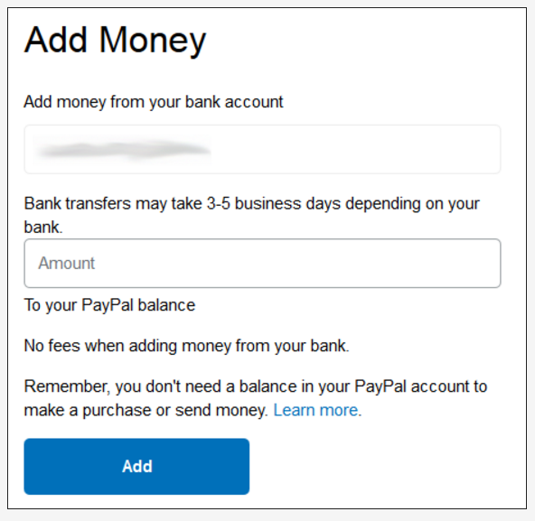

3. Draw money from your PayPal account when you need it
If you need to make a purchase that can't be completed with PayPal, don't sweat it! PayPal allows you to easily transfer money back into your bank account from your semi-anonymous pool on PayPal if liquid cash would be more useful to you in a certain situation.

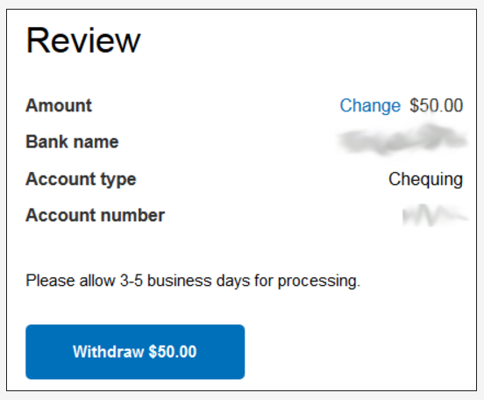

4. Seamless online shopping through PayPal
Millions of websites accept PayPal as payment, and shopping with PayPal is a snap on sites like eBay.com, OverStock.com, and HomeDepot.com! When you go to check out, simply select PayPal as your payment type, log into your PayPal account, and select where you want the money to come from: your bank account, your credit card, or your balance on PayPal. No credit card details required!

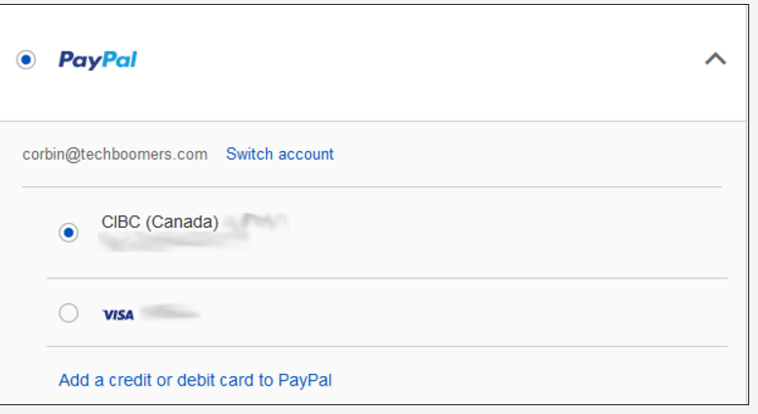

5. Transfer money quickly and easily to other PayPal users
If your friends or family members use PayPal, too, then you can send them money when they need it with just a few quick clicks! Just type in their email address or phone number, choose how much money you want to give them (and in what currency), write them a note if you want, select where the money's going to come from -- your credit card, your bank account, or your PayPal balance -- and send your gift off!

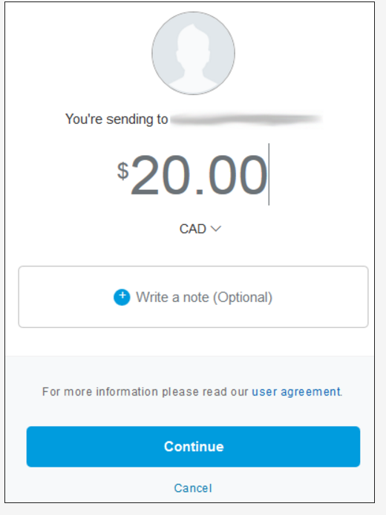

That's an introduction to what PayPal is and what it does! Throughout our PayPal course, we'll teach you everything you need to know to make PayPal your best friend when it comes to transferring money online. We'll show you how to sign up for a PayPal account, transfer money to your PayPal account, use your PayPal account for online purchases, and do all this and more as safely as possible. Let us be your guide for using PayPal to move money online safely and quickly! TechBoomers’ PayPal course: https://techboomers.com/p/paypal

